**OS-Lab Manual**

**Lab: 01**

**Task:**

**Write Linux bash Shell Script, which will ask and display all information required to Student admission in Engineering and Sciences University.**

**Code Screen Shots:**

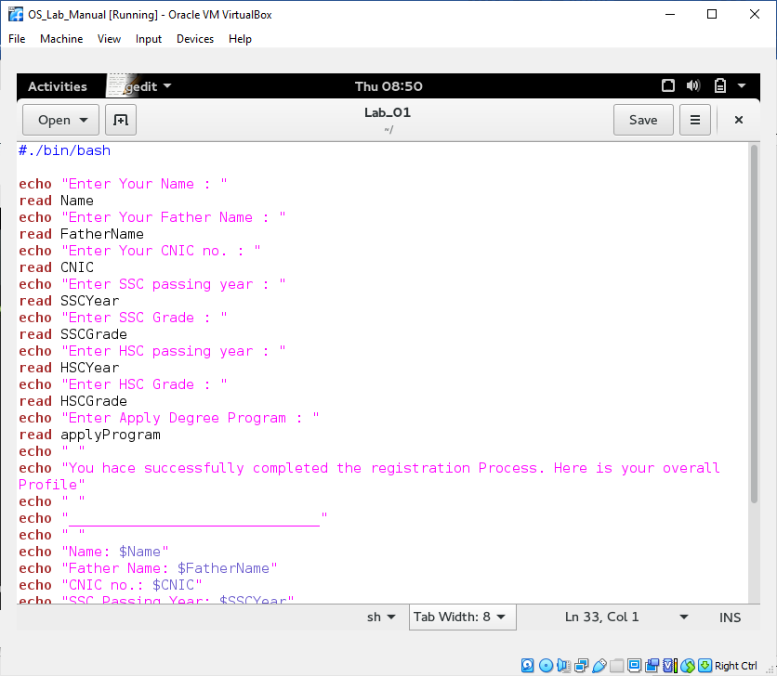

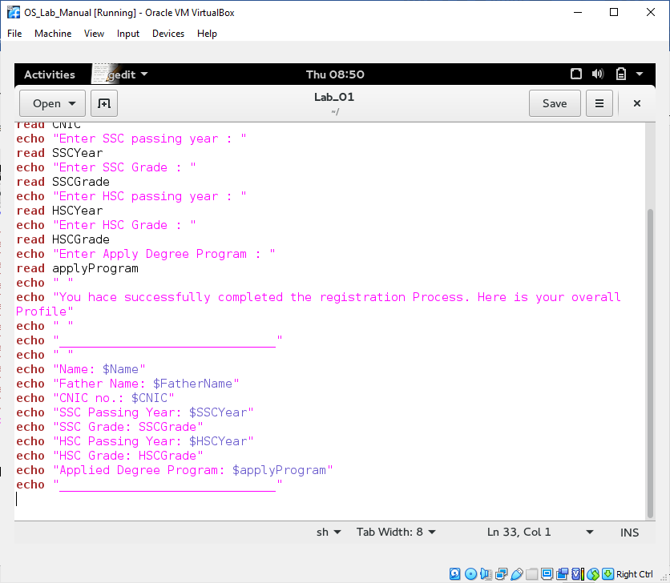

**Code Output Screen Shots:**

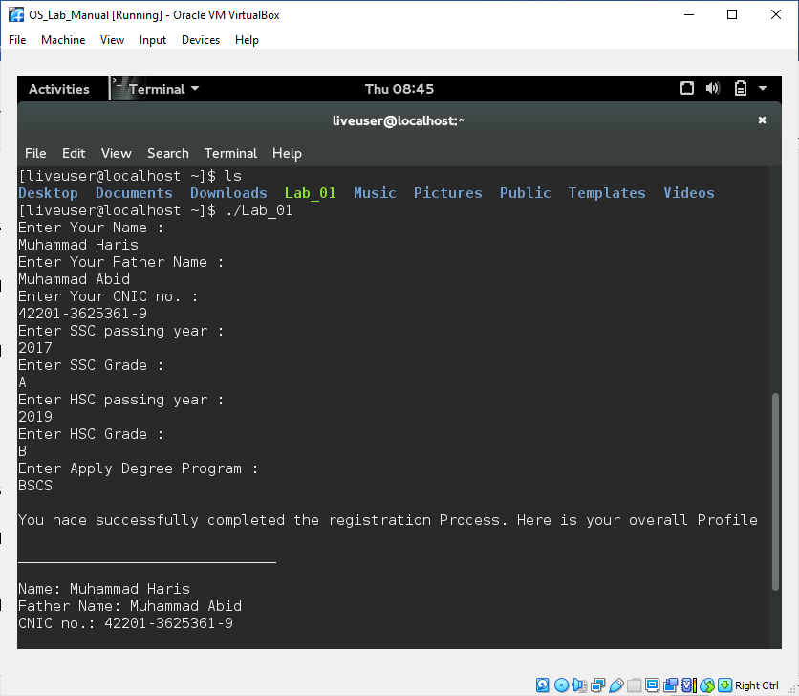

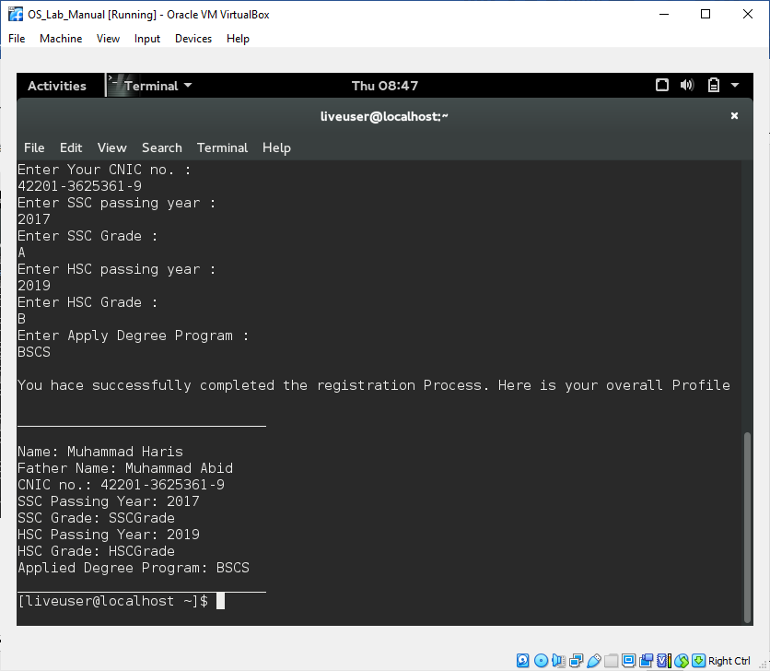

**Lab: 02**

**Task: Use following variables to write your CV in Linux bash script.**

|  |  |  |
| --- | --- | --- |
| **Variable** | **Script** | **Output** |
| **$0** |  |  |
| **$n** |  |  |
| **$#** |  |  |
| **$\*** |  |  |
| **$@** |  |  |
| **$?** |  |  |
| **$$** |  |  |
| **$!** |  |  |

**Code & Output Screen Shots:**

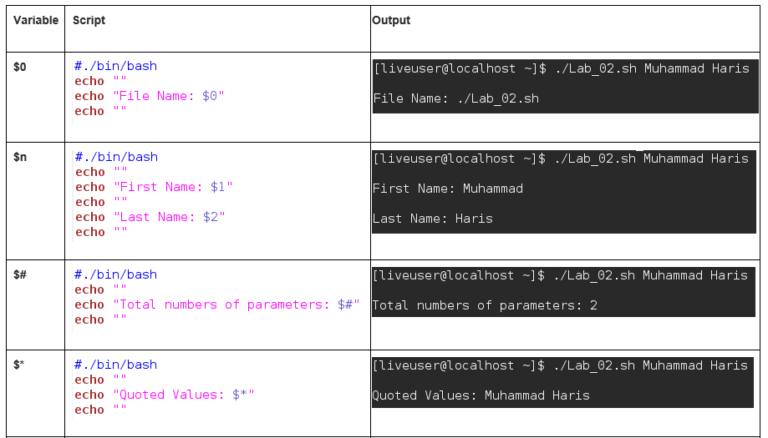

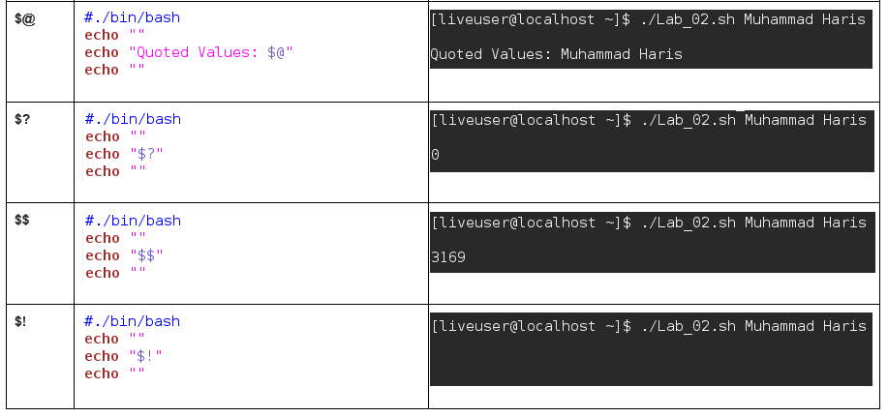

**Lab: 03**

**Task: Write bash scrip to test all Athematic and logical operators in Linux**

|  |  |  |
| --- | --- | --- |
| **Operator: Task** | **Script** | **Output** |
| **+: add two number** |  |  |
| **-: make decrement operator** |  |  |
| **\*: Multiply negative and positive number** |  |  |
| **/: divide any number by zero** |  |  |
| **Less than: Compare two values** |  |  |
| **Greater than: Compare two values** |  |  |
| **EquUniversityty: Compare two values** |  |  |
| **Not equal: Compare two values** |  |  |
| **And: make two simple and gate** |  |  |
| **Or: make two input or gate** |  |  |
| **Not: make 1 input not** |  |  |

**Code & Output Screen Shots:**

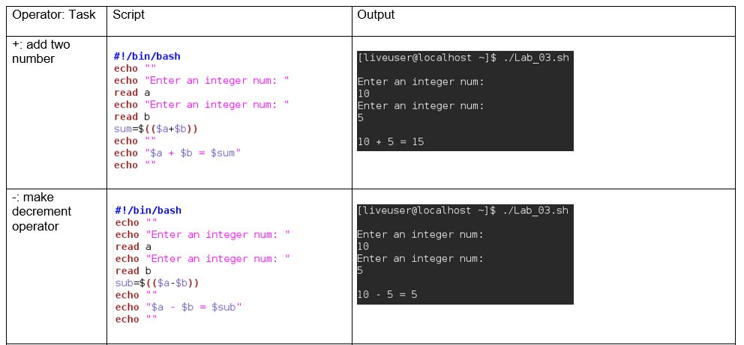

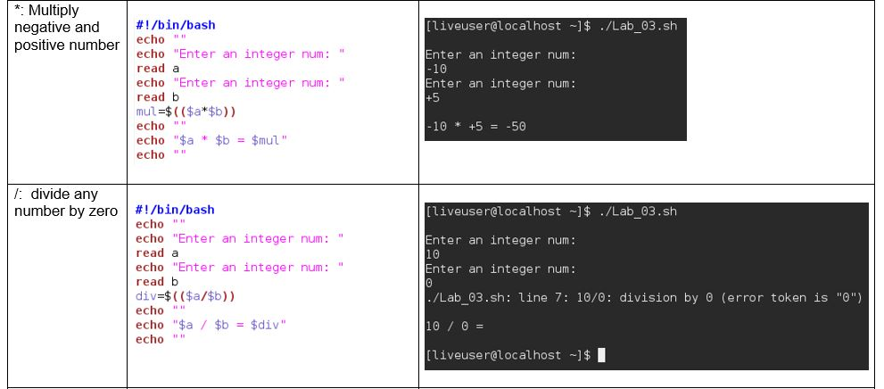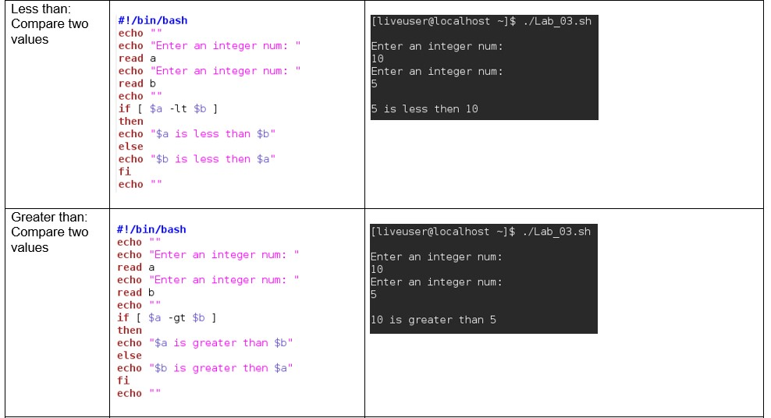

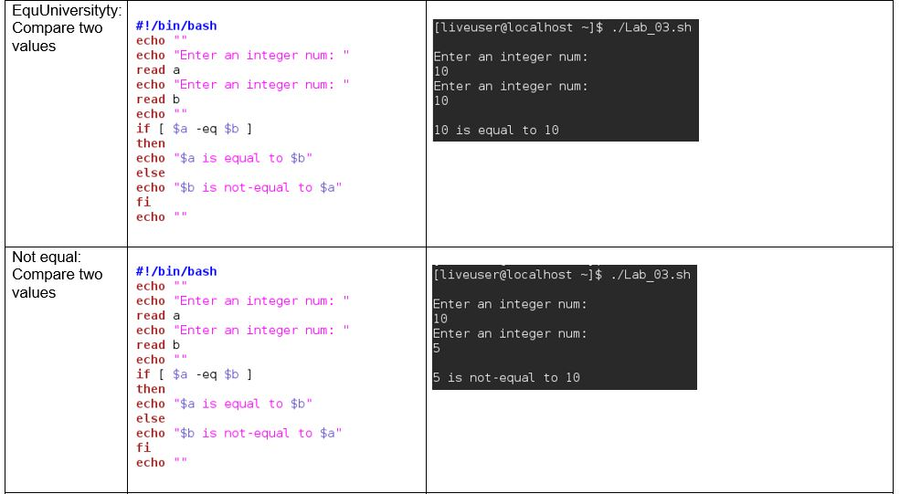

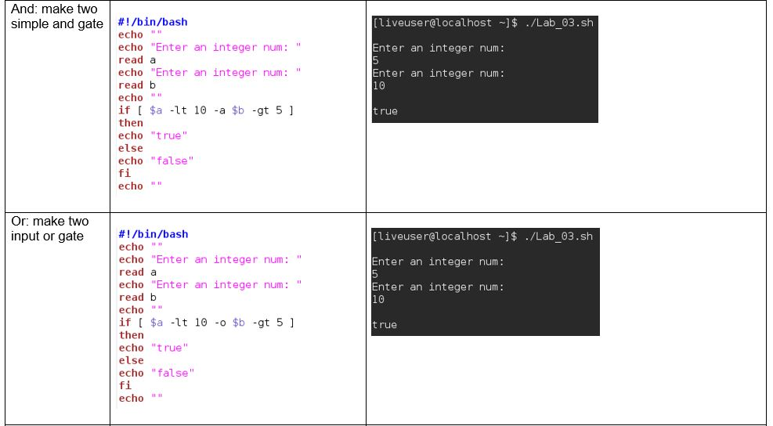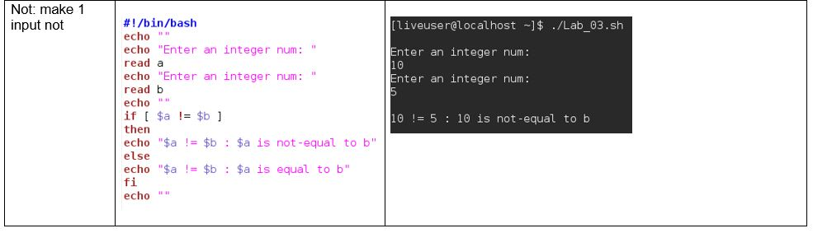

**Lab: 04**

**Task:**

1. **Sort integer Array in ascending order.**
2. **Find shortest value in integer array.**
3. **Make shell function which can find out that input number is prime or not**
4. **Make shell function which can eliminate all odd numbers from integer array.**
5. **Make shell function which can find the last three prime number lesser than 100.**

**1. Sort integer Array in ascending order.**

**Code Screen Shot:**

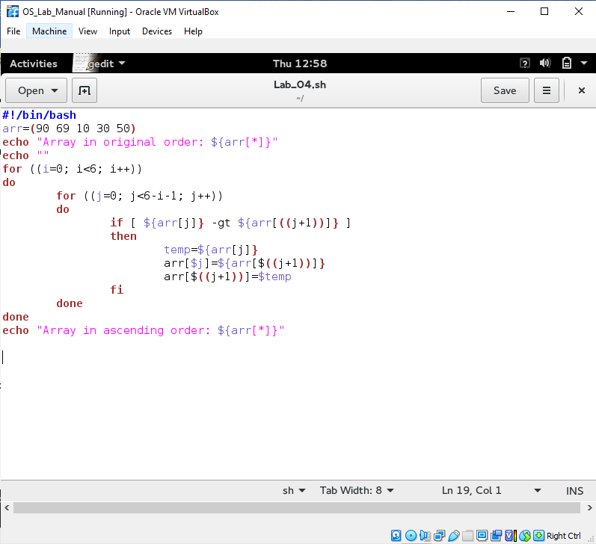

**Code Output Screen Shot:**

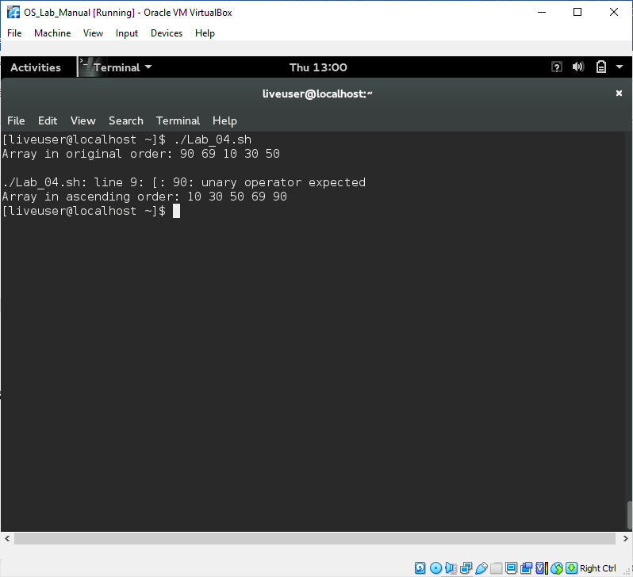

**2.Find shortest value in integer array.**

**Code Screen Shot:**

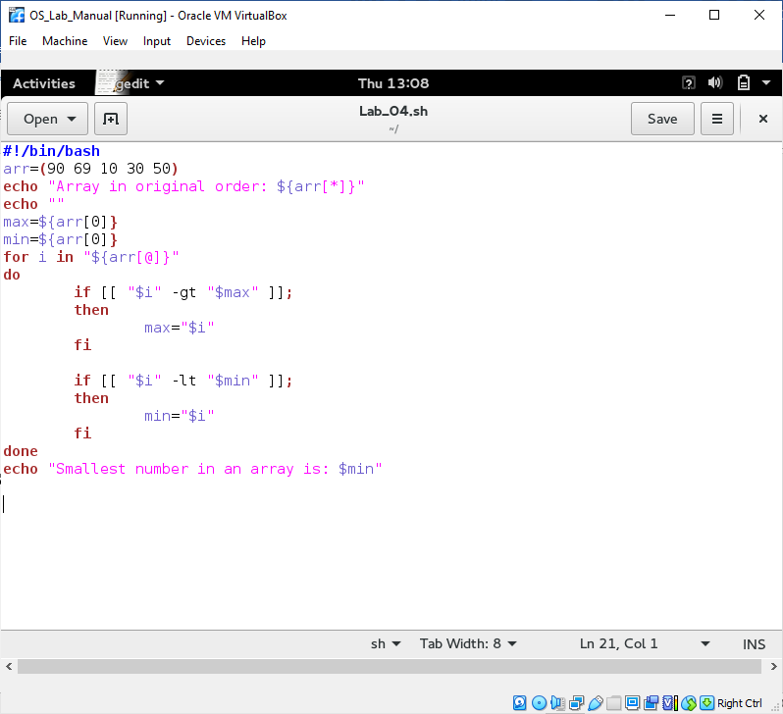

**Code Output Screen Shot:**

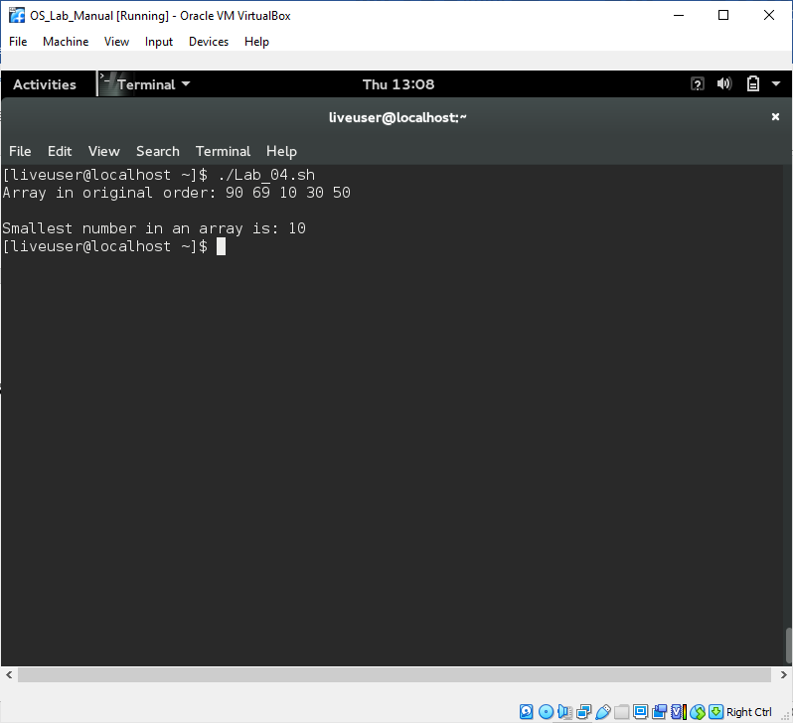

**3.Make shell function which can find out that input number is prime or not**

**Code Screen Shot:**

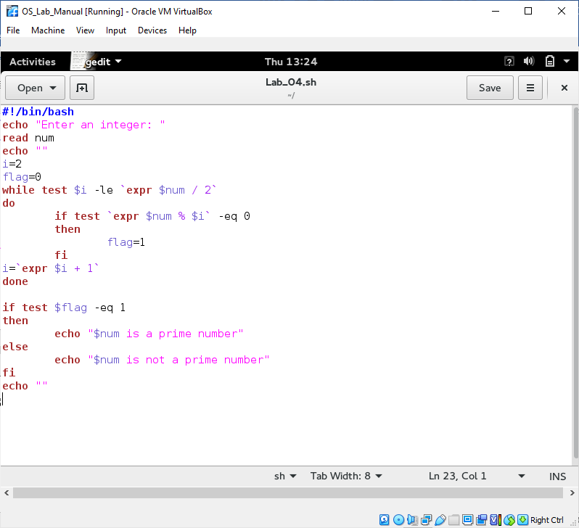

**Code Output Screen Shot:**

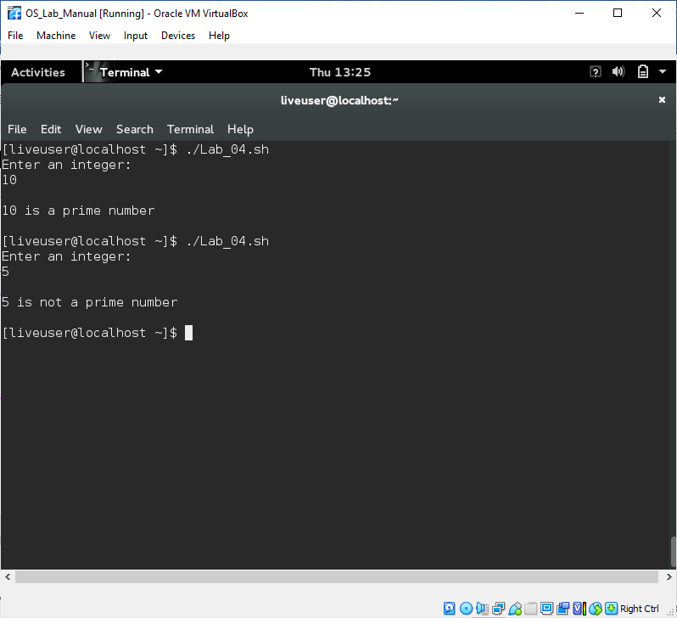

**4.Make shell function which can eliminate all odd numbers from integer array.**

**Code Screen Shot:**

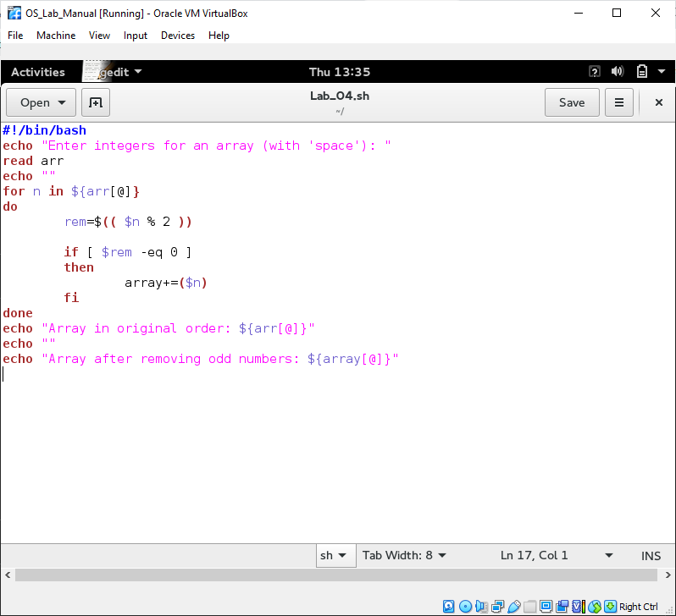

**Code Output Screen Shot:**

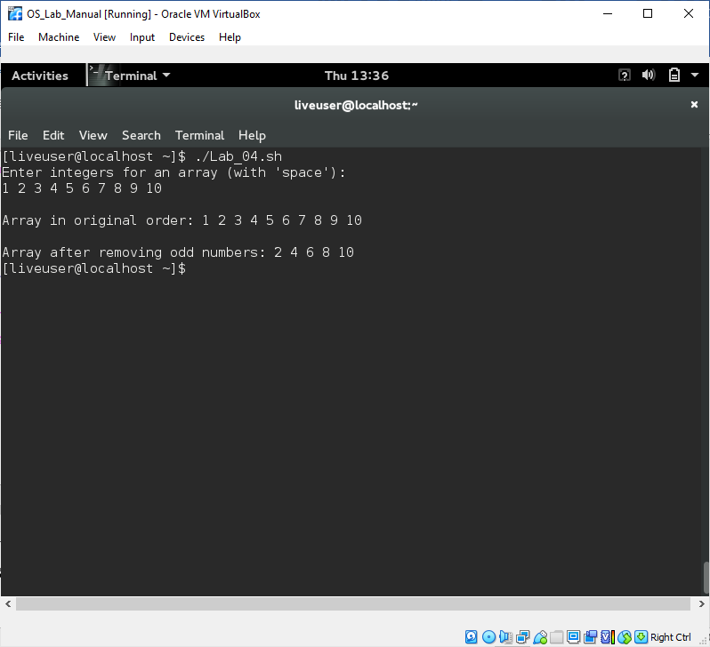

**5.Make shell function which can find the last three prime number lesser than 100.**

**Code Screen Shot:**

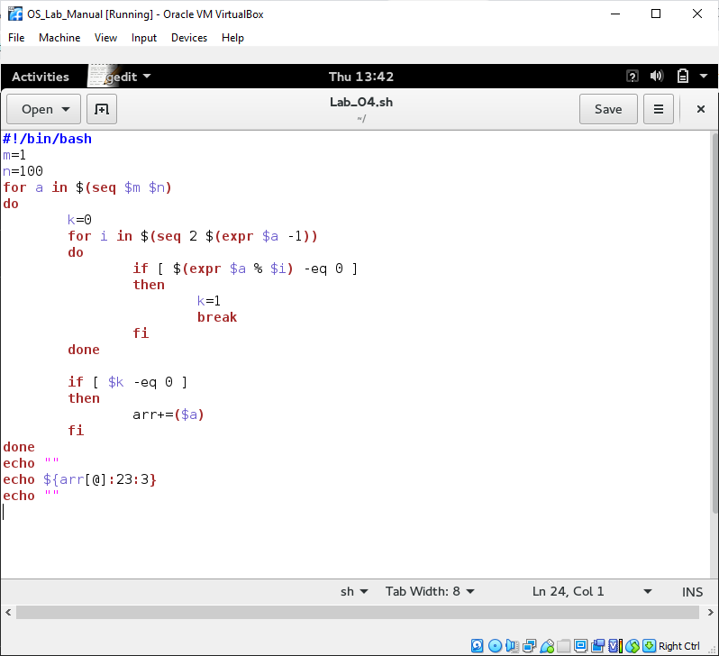

**Code Output Screen Shot:**

